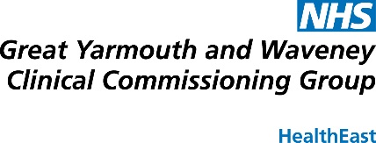
Integrating Public Feedback on Care

Monday 1st December 2014
Kings Centre, NR31 0LE

From 12:15 | Registration and refreshments
12:30 - 13:00 | Welcome and introduction:  - Aims of the afternoon  - Summary of Palliative End of Life Care project | Maggie Parsons, Programme Manager, Cancer, Palliative End of Life Care and Programme Lead for the Norfolk and Suffolk Palliative Care Academy  Tim Hunt, Education Services Manager, Patient Opinion
13:00 – 13:40 | Why Patient and Care Opinion? | Paul Hodgkin, Founder & Chair, Patient Opinion
13:40– 14:10 | Group Session: Exploring the Value of integrated feedback | Tim Hunt  Paul Hodgkin
14:10 – 14:20 | Refreshment break
14:20 -14:30 | Discussion: What does regional implementation look like? | Tim Hunt  Paul Hodgkin
14:30– 15:15 | Group Session: Implementation Planning-Shared Approach. | Tim Hunt  Paul Hodgkin
15:15 – 15:30 | Conclusions and Final Questions | Tim Hunt  Maggie Parsons

